300 – Action
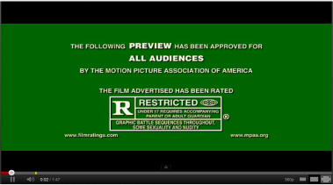  The very first shot is important because it gives vital information to the audience. | 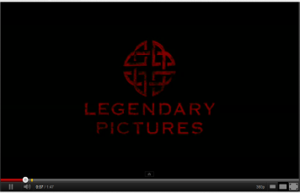  The next shot contains a production company which produced the film. People who like this company will want to see the film more. | 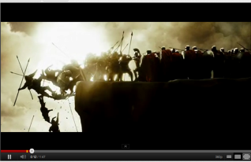  This is the first shot the audience are introduced to showing them a lot of action and makes them wonder what is happening.
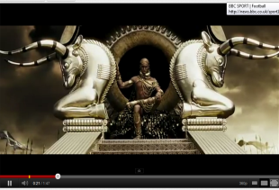  There is a guy sitting in a golden throne with a dark back ground. The audience are introduced to the villain of the story. | 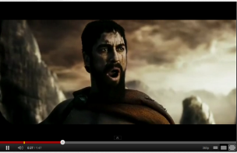  Another character is introduced to the audience, not sure who but looks like a soldier of some sort who has seen a lot of action. | 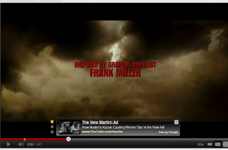  Good shot for the audience because they may want to see more if due to the information on the screen.
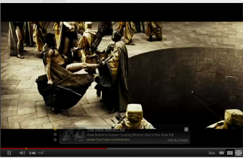  This shot shows the first piece of proper action by the good character the audience were introduced to kicking another character. | 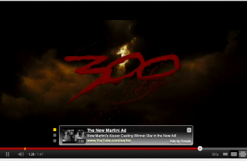  The name of the film appears and it comes towards the end of the trailer so the audience remember it. The font is also blood like to represent the action genre it is. | 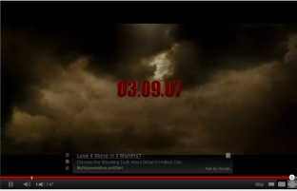  At the very end of the trailer you see these numbers appear on the screen letting the audience lnow the release date. It also appears in the same font as the title of the film.

This trailer is of the action genre and is represented in many different ways throughout the trailer through the actually footage and audio. It starts off with a warning sign to the audience watching saying it is watchable for all ages so parents know it is safe for their kids to watch. This is important because it allows a large audience to view the trailer potentially widening the range of which audience they can aim for. The next few shots shows three different production companies which have helped produce the film and this can help attract an audience because they may like other films which have been produced by these companies in the past. The first proper shot of the trailer of the film shows people falling off a cliff which straight away suggest that there will be a lot of action in this film. It also shows there must be some type of battle going on between two sides and again this is typical of an action film because they normally have good versus evil. The next shot introduces a character to the audience but from the mise-en-scene you can see that this character is the bad guy. He is on a golden throne with a dark background which does suggest there is evil within him. On the other hand in the next shot you are introduced to the good character of the film and even though he doesn’t look like he is the mise-en-scene helps you understand his part in the film. The bright sky behind him is the opposite to the darkness of the throne so instantly you can tell these are opposites. The audience now see some information pop on the screen about the author which may make more people want to come see the film, also the font used is very unique and will help the audience remember it. The next shot goes back to the film where the good character is kicking someone down a hole which introduces the first part of proper action to the trailer; this is where the action starts off in the trailer. The viewers are now being shown the title of the film towards the end of a trailer so the audience remember the title of the film; it is also shown in the same font as the information earlier which shows a clear link that this is the font used for the film. The very last thing that is shown to the audience is the date of release for the film which is again shown in the same font as the previous information. With the title being shown towards the end and the date being shown at the end the audience will be able to remember this very clearly and when discussing this with friends they will tell them this information.
Mise-en-scene
The mise-en-scene plays a massive part in this trailer for a few reasons. First of all it helps the audience figure out who is on what side, so for example the man in the throne is evil because of the black background to his golden throne. Also the mise-en-scene helps set the year is was set and this is done by the clothes worn by the characters and also the weapons used in the battles that are fought in the trailer. Lastly it helps show that the genre of the film is action and this is through the battles in the trailer and the general way the characters are portrayed throughout the whole trailer.
Narrative
The narrative in this trailer isn’t all that clear because it has bits and pieces of what looks like a few different battles during the trailer. What the audience can gather from the trailer though is that a small group of soldiers go out to fight a battle against many evil soldiers but the trailer doesn’t give away how the battle ends or who wins. At the end you see the good main characters standing with his back to the audience with a few arrows in him which makes the audience wonder what will happen to him and makes the audience want to find out and come back to see the film when released.

Sound
The diegetic and non-diegetic sounds play a massive part in this trailer because it makes the audiences adrenaline start to pump at the moment when the action starts to pick up the pace. The sound in the trailer also helps the audience understand what is happening and part of the story which the trailer shows. The diegetic sounds during the trailer also show the film being advertised in the trailer is of the action genre because the war noises and the clanging of swords which suggests there is a lot of fighting. Throughout the trailer the non-diegetic sound of the background music slowly builds up and then gets louder as soon as the fighting starts in the trailer and then when it stops the music quiets back down so the audience can concentrate of what’s happening back on the screen.
Target Audience
The target audience for this trailer is quiet large but is aimed at young men between the ages of 16 – 30 and this is shown via the actors. All the actors are between the ages of 16 – 30 and this will help attract the target audience they are looking for because of the specific actors being used. The genre of the film also appeals more to male gender because of the gore and fighting which happens and the trailer also shows parts which are quite clearly not for kids and this rules out the aim for a younger target audience.

